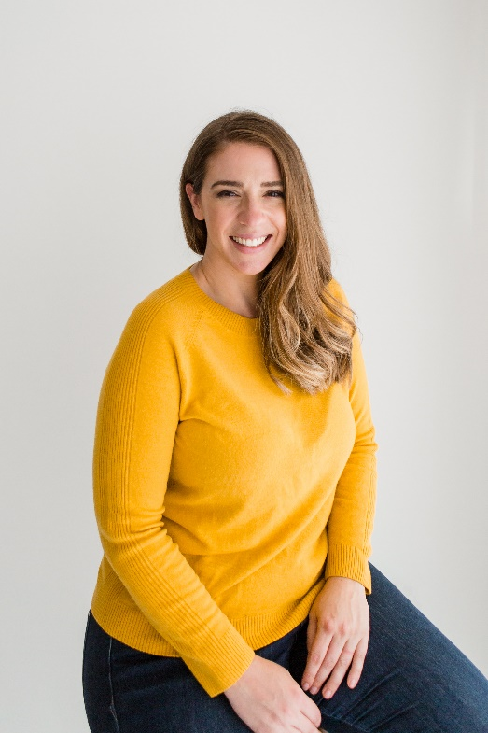

Lauren Bradley

Lauren Bradley is the founder of The Officials, an online platform that empowers assistants through community, courses and coaching. She is passionate about providing affordable and accessible training to the industry. Her career as an award-winning assistant and business owner spans nearly twenty years, where she has worn many hats including office manager, executive assistant, virtual assistant and private PA to HNWIs.
A truly international powerhouse, Lauren is a corporate trainer, mentor and speaker. She is originally from Pittsburgh, PA but now lives in London with her family where you can find her constantly neglecting her cup of tea.
Awards
- 2022 eLearning Businesswoman of the Year (UK) by Acquisition International
- 2022 Most Empowering Administrative Support Training Company, The Officials by SME News
- 2019 Rising Star [Highly Commended] at the Sutton Women Mean Business Awards
- 2016 OfficeNinjas‘ All-Star Award Winner

